

W6 PRACTICE
FORMS & INPUTS
 What are the objectives for this session?
- Learn and use various HTML form input types o text, checkbox, radio, dropdown, text area, range, color, selector etc.

- Apply basic CSS styles to enhance the appearance of form inputs o borders, colors, padding, margins etc.

- Use: :focus :hover : checked :checked :indeterminate CSS pseudo-classes

 How to start?
- Download the start code from the LMS
- Open the folder in VS Code
How to submit your work?
- Push your final code on your GitHub repository
- Then attach the GitHub path to the MS Team assignment and turn it in

 Are you lost?
You can read the following documentation to be ready for this practice:
- Guide - WC3 School
- The Form element
- HTML Forms



PART 1: LEARN – 45 MIN

- Read or watch resources on internet to learn about HTML Inputs:
Guide - WC3 School
The Form element
HTML Forms

- Complete the bellow table.

INPUT TYPE | USAGE | EXAMPLE
Text | defines a one-line input field for text input | <input type="text">
radio | allows the user to select one option from multiple choices | <input type="radio" name="gender" value="male">
checkbox | allows the user to select one or more options | <input type="checkbox" name="hobby" value="music">
range | allows the user to select a value from a slider control | <input type="range" min="0" max="100">
submit | creates a button that submits the form | <input type="submit" value="Submit">
textarea | allows multi-line text input | <textarea rows="4" cols="30"></textarea>
select | creates a dropdown list | <select><option>Option 1</option></select>
color | lets the user pick a color from a color picker | <input type="color">
file | allows the user to upload a file | <input type="file">

- Read or watch resources on internet to learn about Inputs styling:
https://www.w3schools.com/css/css_form.asp
- Complete those mini challenges by writing your code on bellow table:

MINI CHALLENGES | YOUR CODE (HTML + CSS)
Highlight the input field when it is focused | <input type="text" class="focus-input">  <style>  .focus-input:focus {  border: 2px solid dodgerblue;  background-color: #eef6ff;  outline: none;  }  </style>
Change the button background color on hover | <button class="hover-btn">Hover Me</button>  <style>  .hover-btn {  padding: 10px 20px;  background: #444;  color: white;  border: none;  cursor: pointer;  }  .hover-btn:hover {  background: #1e90ff;  }  </style>
Create a search bar with rounded corners and a shadow effect | <input type="text" class="search-bar" placeholder="Search...">  <style>  .search-bar {  width: 250px;  padding: 10px 15px;  border-radius: 25px;  border: 1px solid #ccc;  box-shadow: 0 3px 8px rgba(0,0,0,0.15);  }  </style>
Display a different style when the checkbox is checked | <label>  <input type="checkbox" class="styled-check">  Check me  </label>  <style>  .styled-check:checked {  outline: 2px solid limegreen;  accent-color: limegreen;  }  </style>
HARD!  Style a checkbox to have three states: unchecked, checked, and indeterminate.  TIP  Use CSS pseudo-classes  (:checked and :indeterminate) for styling. | <input type="checkbox" id="triCheck" class="tri">  <style>  .tri {  width: 20px;  height: 20px;  accent-color: black;  }  .tri:checked {  accent-color: green;  }  .tri:indeterminate {  accent-color: orange;  }  </style>  <script>  document.getElementById("triCheck").indeterminate = true;  </script>

- Some groups will be selected to present and explain their work to the whole class

PART 2: PRACTICE – 45 MIN

You need to reproduce – as close as possible - the bellow table.

Before coding, identify the following point:

- Elements: What are the different inputs you will need?

- Layout: what kind of CSS layout do you need? Why?

- Input styling: What are the styles you need to apply on your inputs?

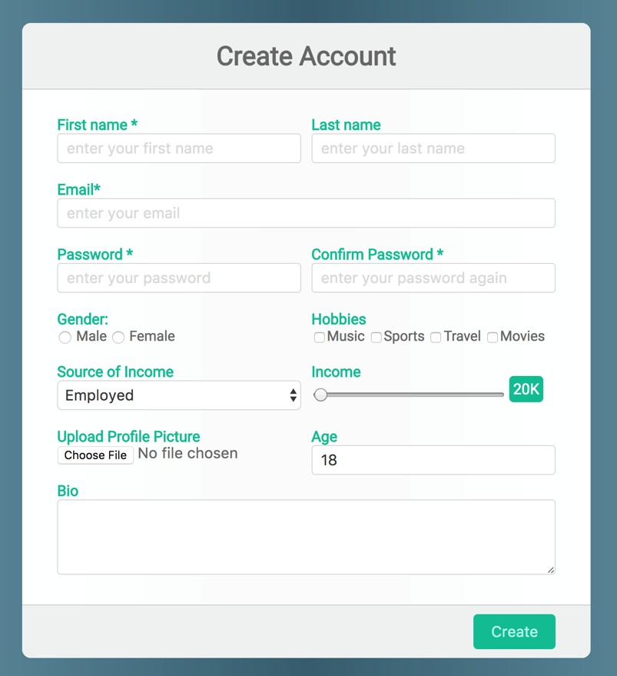
Be as close as possible from this mock up

